
  - MyAccount Download Section / J905596 Veritas Press, LLC

Functional Requirements Document (FRD)

Copyright© 2017, Oracle and/or its affiliates. All rights reserved.
Any reproduction or distribution of any part of this document without the prior written permission of Oracle + NetSuite is strictly prohibited.
The information included in this document is confidential and proprietary information of Oracle + NetSuite.
Version: January 12, 2015

Oracle + NetSuite
2955 Campus Drive, Suite 100
San Mateo, CA. 99403-2511

Project Information
Customer Name (Number) | Veritas Press, LLC
Job Name (Number) | J905596
Document Owner | Piyush Kayastha
Solution Architect | Ilan Daniele
Project Manager | Billy Flores

Document Version History
Rev | Date | Author(s) | Change Summary
1.0 | 02/17/2023 | Piyush Kayastha | Initial Draft
1.1 | 02/17/2023 | Ilan Daniele | Added Few Notes
1.2 | 2/21/2023 | Piyush Kayastha | Responses provided
1.3 | 2/21/2023 | Ilan Daniele | Added modifications

Business Requirements
Customer requires a section added to My Account touchpoint of SS4C website to include a way for their customers to view Download Items they have purchased and to be able to download those items from within that My Account section. Similar to how a customer would view their Invoice PDF.

Solution Overview
- Create up to one (1) page view on the MyAccount section to list Downloadable Items purchased by the user where we’ll list Date, Item number, Description and Link.
If the list of items purchased with downloads is empty, a message displaying “No recent downloads” will show up.
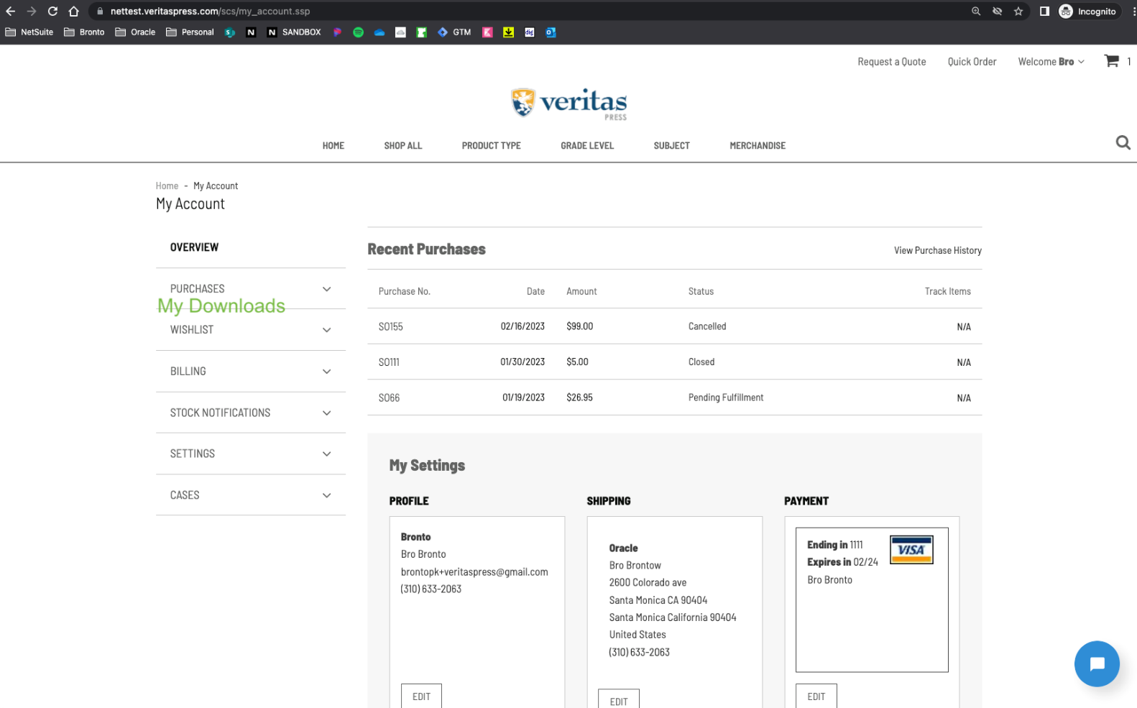
This list be filled up with the Items (sales orders) that have been purchased by the client, provided by the client on a Saved Search.

The content of the section can look like the following content:
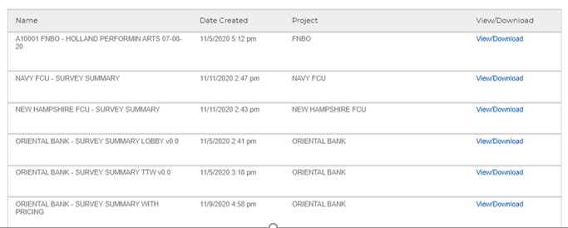
With info: Item Name/Number, Date, Description, and Link.
This link should allow the customer to download the file associated to the item purchased. The customer has set the default folder location on the item form to map files to the download item, on Web Site Hosting Files > Live Hosting Files > site > assets > Downloads. (Better to have the url associated directly on the saved search so we can fetch it directly from the saved search record, could it be?)
How was build the downloadable items? Does this use the native download function?
Downloadable item is a native item, but they are not treated natively on the webstore, and we have to build a new section.
Are they related
How is the customer relating a downloadable file with himself? Where is the association coming from? Not the folder.
Does the download expire? Do they have a limit of downloads? Pagination?

It’s a functionality in the core, it’s not on SCA.
What do you mean by downloadable items?

Test Case

Test Case 1

Test Case 2

Assumptions
Customer will be setting up all of their download items. This section will be primarily for digital download items their customers would purchase through the SuiteCommerce webstore.
Customer will provide a saved search with all the sales order with inventory items for every client. Guidance have to be provided to them in order to create the needed Saved Search.
Yes. Will need some clarification from you on what type of Saved Search you will need. You don’t have to specify all the criteria but at least whether it is a Customer Saved Search, Transaction, etc.

Acceptance
Oracle + NetSuite Professional Services and Customer are in agreement that the information documented above is accurate and representative of the customer’s business needs. This document will act as the basis for all subsequent implementation activities.
Delivery Date: 06/12/2019
Document Version: 1.0

Oracle + NetSuite Acceptance
Action | Name | Title | Signature | Date
Accepted By |  | Project Manager
Accepted By |  | Consultant

Customer Acceptance
Action | Name | Title | Signature | Date
Accepted By |  | Project Manager

